**Lab 5: Design a Calculator App using Edit Text view and Command Button.**

1. The layout is created for a basic calculator application, featuring a clean and user-friendly interface.
2. It offers an intuitive experience for users to input numbers, perform arithmetic operations, and view the results.
3. Users can enter the first and second numbers for calculations using the input fields.
4. The Java code sets up the interface, handles button clicks, performs calculations based on user input, and displays the result.
5. It also validates user inputs and provides feedback if any errors are detected.

**XML Code:**

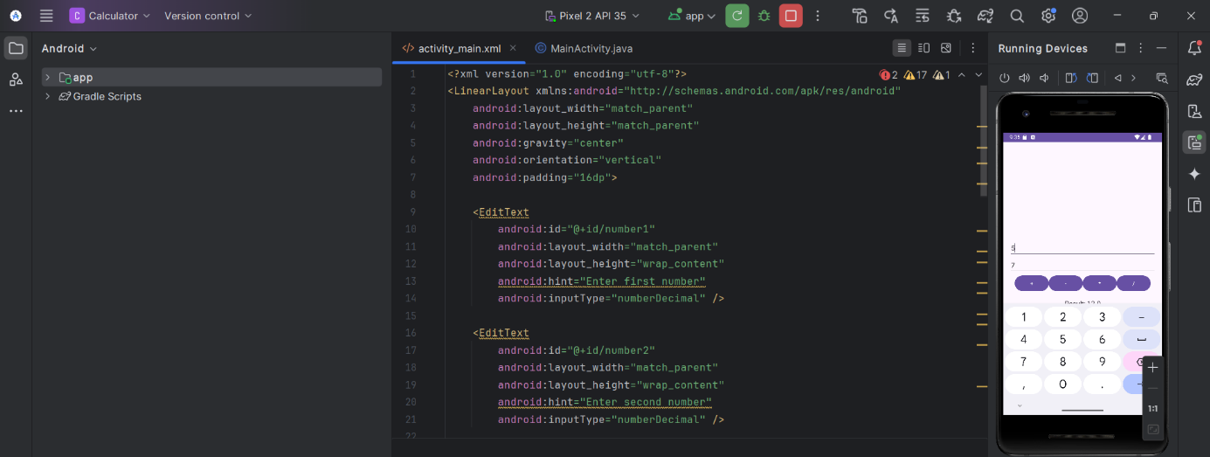

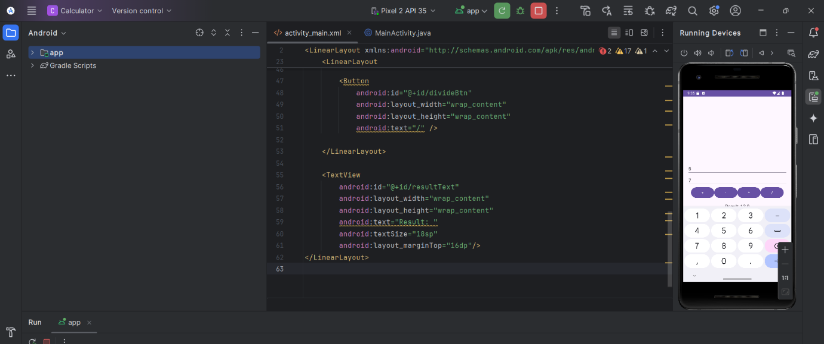

**Java Code:**

